Store Manager: Keep Track of Inventory

Team Details:

Team ID : NM2025TMID40176

Project Title : Store Manager : Keep Track Of Inventory

Team Leader:N.Manimaran

Team members:Santhoshkumar.D,lokeshwaran.p, sarveshwaran. D

Objective:

The objective of this project is to design and develop a comprehensive Inventory Management

System that enables eﬃcient tracking, updating, and management of stock in a store. The system

aims to simplify day-to- day inventory operations by providing real -time stock updates, automated

alerts for low stock, and streamlined sales management through cart and checkout features.

The system will allow users to:

Maintain accurate inventory records with seamless updates on sales and new stock additions.

Facilitate quick and eﬃcient sales through a cart and checkout mechanism while ensuring inventory consistency.

Add and manage new products with essential details like name, image, price, stock, and tags.

Provide alerts for depleting stock levels to support timely replenishment.

Enable easy search and retrieval of products from the inventory and product catalog. Keep a record of all sales with details such as sale value, products sold, and date/ time for accountability and reporting.

This project ultimately seeks to enhance eﬃciency, accuracy, and visibility in inventory and sales

management, reducing manual effort and minimizing the risk of stockouts or overstocking.

Platform & Technology Used :

The project is developed as a web- based application to ensure accessibility and ease of use across

devices with a modern browser. The following technologies and pla ƞorms are used: **React**: A powerful JavaScript library for building interactive and component -based user interfaces. It provides eﬃcient rendering and state management for the inventory system. **HTML**: Used for structuring the web pages and defining the content of the application.

**CSS**: Utilized for styling and designing a responsive, user -friendly, and visually appealing interface.

**Java Script** : The core programming language used for implementing business logic, interactivity, and communication between components.

**Git**: A version control system used for managing code, tracking changes, and maintaining project versions effectively.

Implementation / Process:

The implementation of the Inventory Management System follows a structured process to ensure

smooth handling of products, sales, and stock updates. The workflow can be summarized as follows:

1. **Adding Products to Inventory**

New products can be added by entering details such as product name, image URL, price, stock quantity, and tags.

Products are then displayed in the product catalog and inventory list.

1. **Stock Management**

The system maintains real- Time stock levels.

When new stock is added, quantities are updated in the inventory. On the sale of products, stock is automatically deducted.

1. **Cart Management**

Users can add products to the cart along with their desired quantity. The cart allows multiple products to be selected for a single sale.

1. **Checkout Process**

On checkout, the system clears the cart, updates the inventory, and creates a new sale record.

Each sale record contains the product details, total sale value, and the date/ time of purchase.

1. **Stock Alerts**

Products with stock levels falling below a defined threshold are highlighted with a red background.

Alerts help users take timely action to restock and avoid stockouts.

1. **Search Functionality**

Users can search for products in both the catalog and inventory by name or tags. This improves eﬃciency in locating and managing products.

1. **Sale Records**

The system maintains a history of all sales.

Records can be reviewed to analyze sales trends and inventory turnover.

Output / Result:

**Project structure:**

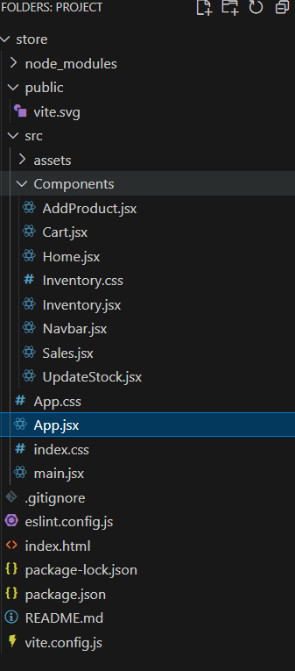

**Inventory :**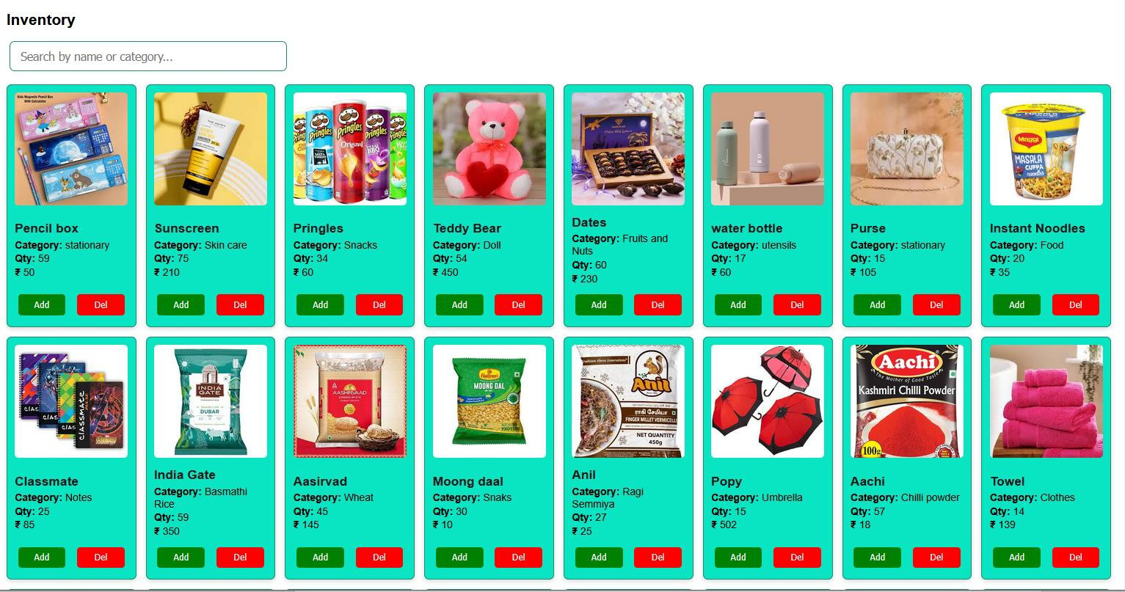

**Sales Record:**

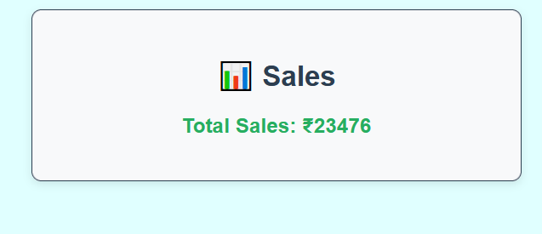

**Add Products**:

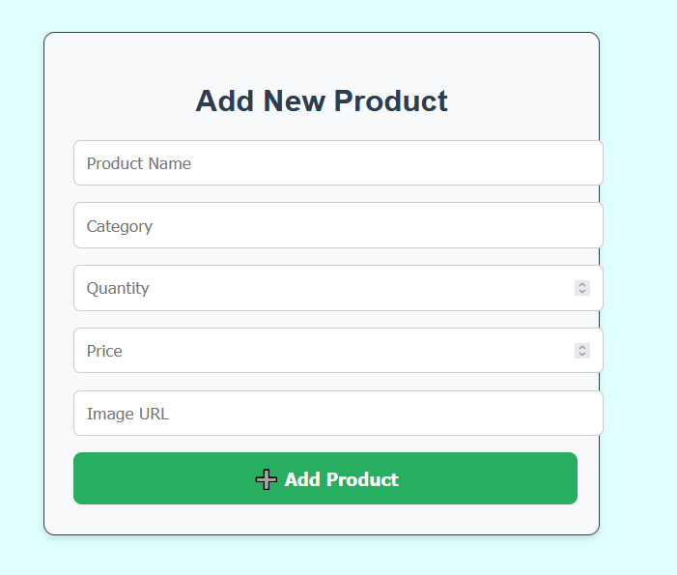

**Cart:**

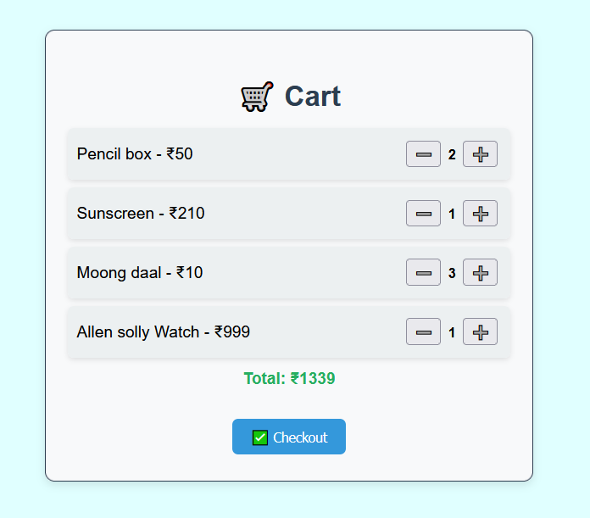

The system meets its objective by ensuring eﬃcient inventory tracking, real- time updates, and accurate sales records, reducing manual errors and improving store management.